**QUESTION 1:**

Task 1 , Task 2,Task 3:

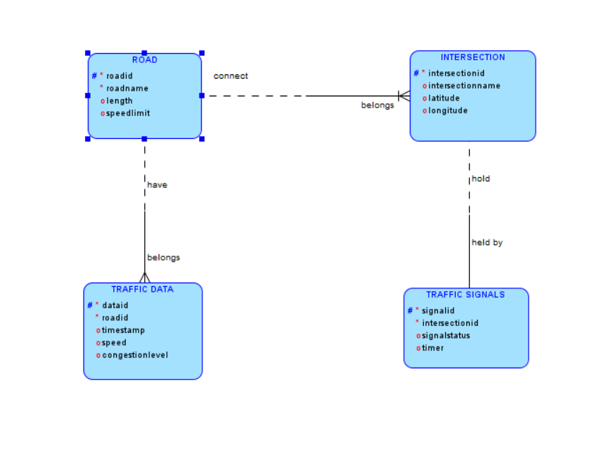

Task 4:

Justification

**1)Scalability**

The design allows for the addition of more roads, intersections, traffic signals, and traffic data without affecting existing data.

**2)Real-time Data Processing**

Real-time traffic data is linked to roads, enabling efficient route optimization and traffic signal control.

**3)Efficient Traffic Management**

The relationships between roads, intersections, and traffic signals allow the system to manage and control traffic flow dynamically.

Normalization

**1)First Normal Form (1NF):**

All attributes contain atomic values. Each entity is well-defined with unique identifiers (primary keys).

**2)Second Normal Form (2NF):**

All non-key attributes are fully functional and dependent on the primary key. For example, RoadName, Length, and SpeedLimit depend on RoadID.

**3)Third Normal Form (3NF):**

There are no transitive dependencies. For instance, Intersection attributes depend only on IntersectionID, and Traffic Signal attributes depend only on SignalID and IntersectionID.

Entity Definitions

**Roads:** Represents the network of roads in the city.

**Intersections:** Represents the points where roads meet.

**Traffic Signals:** Represents the signals installed at intersections to regulate traffic.

**Traffic Data:** Represents real-time traffic data collected from sensors.

Relationship Descriptions

**Roads to Intersections**: Roads connect to multiple intersections.

**Intersections to Traffic Signals:** Each intersection hosts one traffic signal.

**Roads to Traffic Data:** Roads have multiple traffic data entries over time.